1.1 Download PicPick(Portable) for PrintScreen
- http://201708.mediafire.com/file/y106kx03wga3qqx/PicPickPortable_4.2.8_azo.exe

1.2 Install PicPick and Put the folder to the path you want
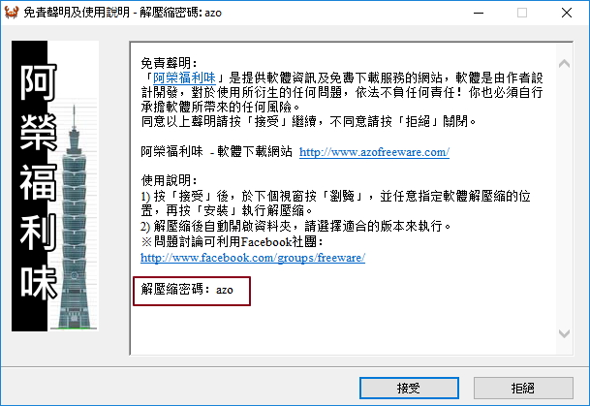
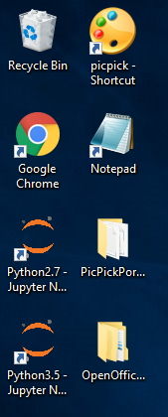
1.3 Open the software and you can start to use it.

2.1 Download OpenOffice(Portable) for Office Processing (Word/ Excel)
- http://201708.mediafire.com/file/1zfob5671bb0bs7/OpenOfficePortable_4.1.5_azo.exe

2.2 Install OpenOffice and Put the folder to the path you wan
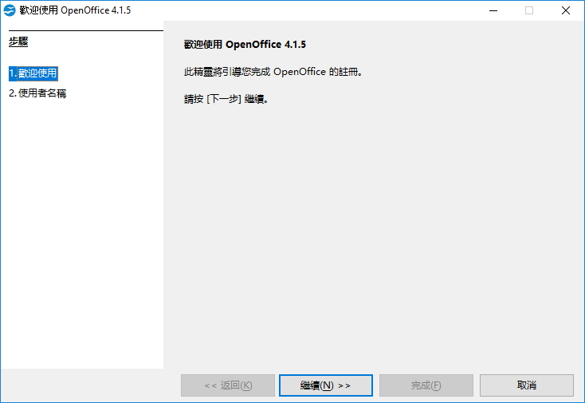
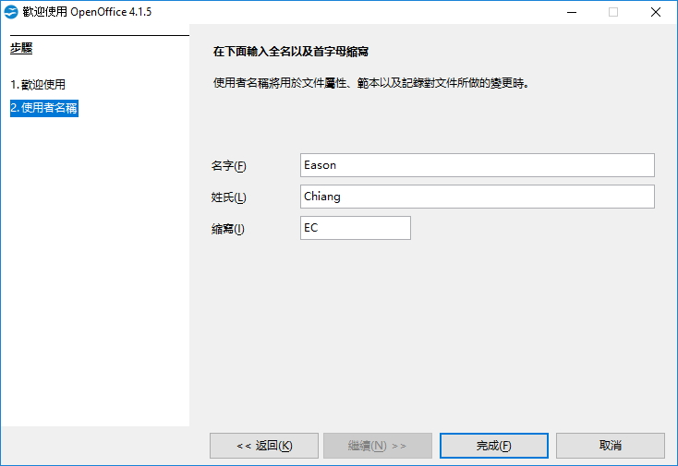
2.3 Open the software and you can start to use it.
